Abstract ACR

Durability of clinical remission in rheumatoid arthritis based on various criteria
Femke H.M. Prince¹, Vivian P. Bykerk¹, Nancy A. Shadick¹, Jing Cui¹, Michelle Frits¹, Christine K. Iannaccone¹, Michael E. Weinblatt¹, Daniel H. Solomon¹
¹Division of Rheumatology, Immunology and Allergy, Brigham and Women's Hospital, Harvard Medical School, Boston, USA

Background: The treatment target of Rheumatoid Arthritis (RA) is remission. Clinical remission can be defined by several criteria, but only one incorporates time as a variable. There are few data about the duration of remission by any criteria. The study aim was to describe the duration of remission periods in RA patients from the Brigham and Women's Rheumatoid Arthritis Sequential Study (BRASS), using different remission criteria.
Methods: BRASS is a prospective, observational, single-center cohort of RA patients. Patients are prospectively followed, and their RA is managed according to the preference of the treating rheumatologist. Disease activity of patients was evaluated annually and remission was defined by: Disease Activity Score 28 (DAS28<2.6), ACR, Clinical Disease Activity Index (CDAI<2.8) and Simplified Disease Activity Index (SDAI<3.3). For the analyses we only included patients with: 1) at least two years follow-up; and 2) at least one remission time-point with subsequently 12 months or more follow-up. First remission time point for each patient was considered baseline. Analyses were performed using Kaplan-Meier survival curves and differences were analyzed using the log-rank-test.
Results: Of the 1095 RA patients in BRASS, 846 had at least two years follow-up. When we considered the different remission criteria for all 846 patients, 408 were in remission at at least one time-point (with 12 months follow-up) according to the DAS28 (n=395), ACR (n=28), CDAI (n=169), or SDAI (n=98). At entrance of the BRASS cohort, median age of the 408 patients was 56 years, 83% were female, 64% were anti-cyclic citrullinated peptide or rheumatoid factor status positive, and median disease duration was eight years. Overall median survival time of remission was two years. Time in remission according to the different remission criteria is shown in the Figure (Kaplan-Meier curve). Probability of maintaining remission at the subsequent examination was significantly higher for the DAS28 criteria compared with the CDAI (p=0.029) and SDAI (p=0.030). The difference between duration of remission for DAS28 and ACR criteria was non-significant (p=0.57), however only few patients met the ACR criteria and no data were available for more than two years.
Conclusion: This study shows that approximately 50% of the RA patients who reached clinical remission maintained this state after one year. Even after multiple years in remission, patients can still drop out of remission. Whether patients are considered to be in clinical remission depends on the criteria used.

Funding: FP is funded by the Niels Stensen Foundation, The Netherlands

Figure: Duration of RA remission based on various remission criteria
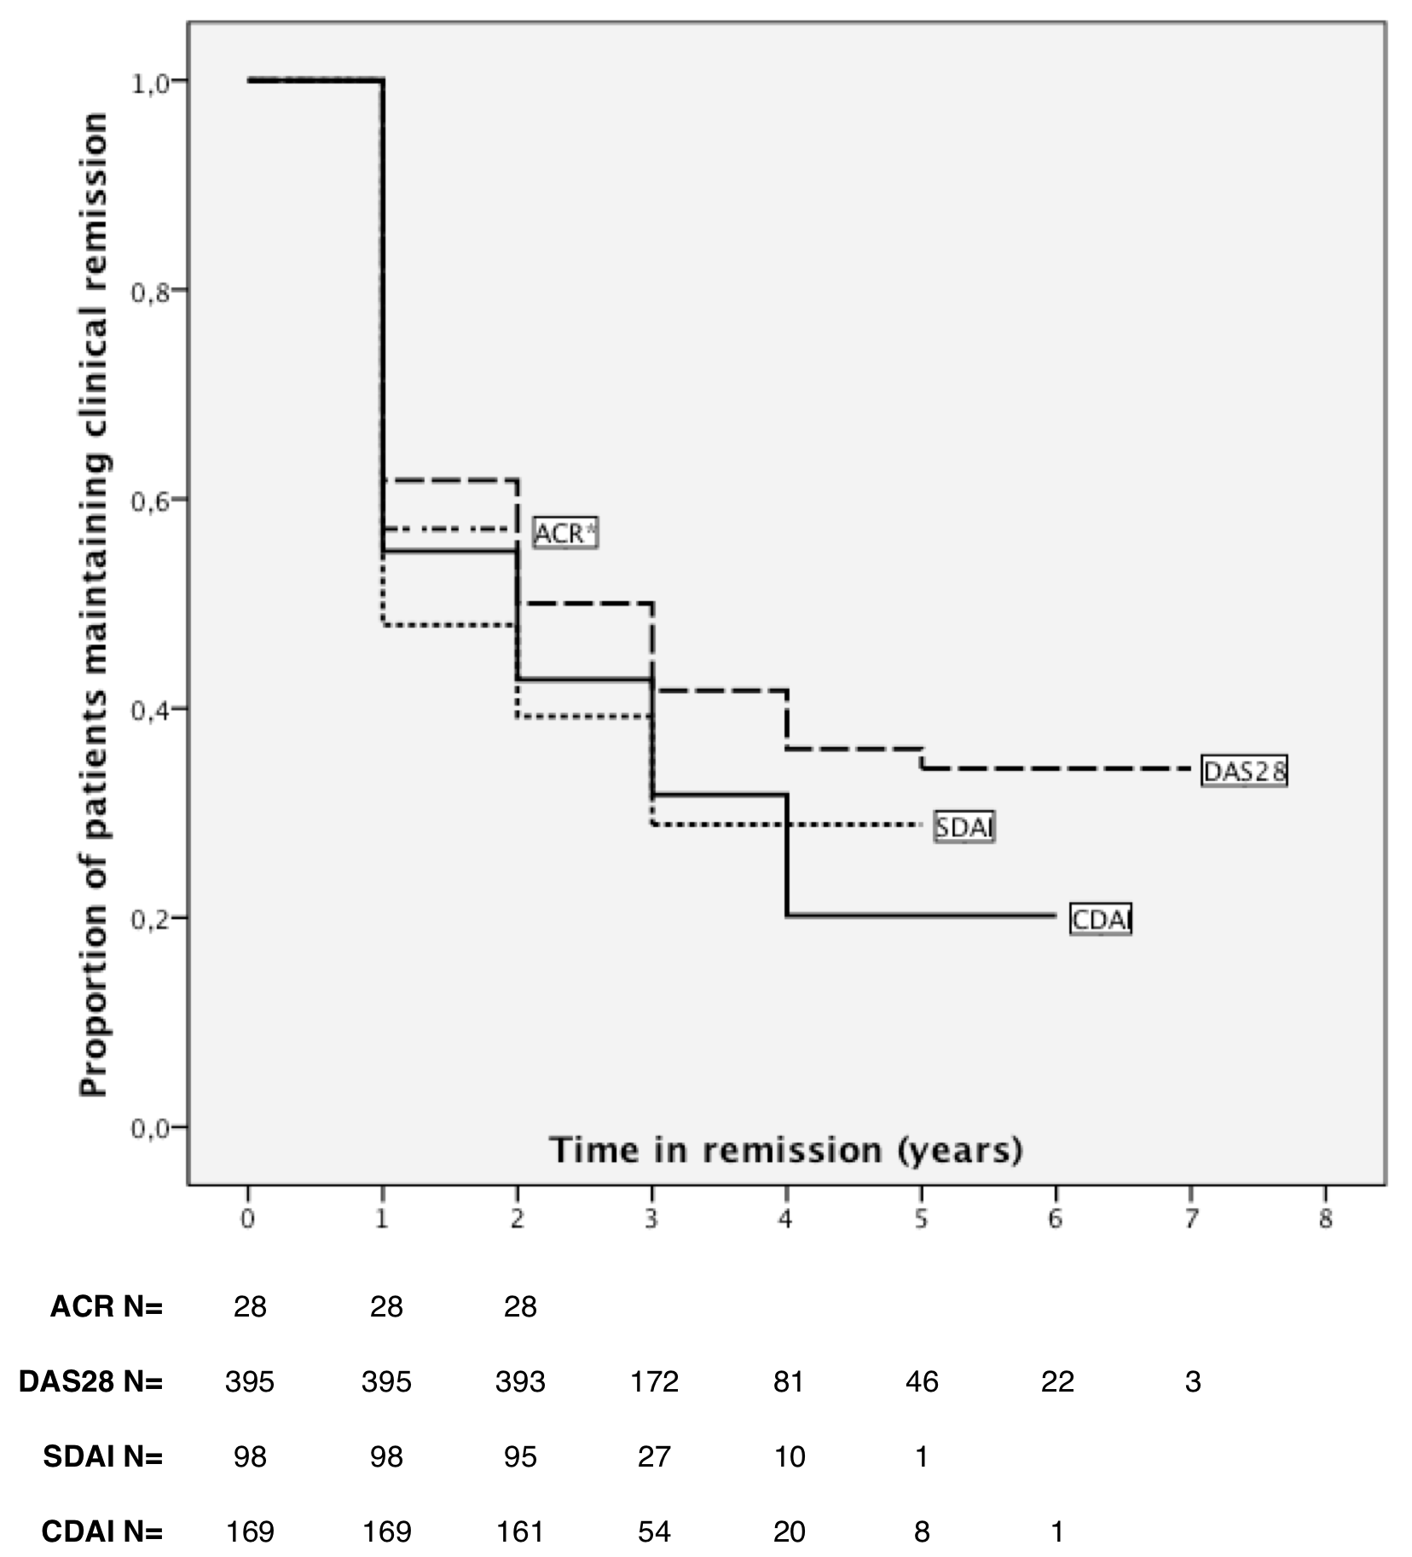

*ACR curve stops at 2 years

